Task 1: Exploration of Data Visualization Tools like Tableau, Python libraries, D3.js
• Connecting Dataset
• Preparation of data
1.a)Extent a dataset by list the attributes in any one of the format (CSV,Excel) .
- Import python libraries whatever needed.
- Read and display the details of the dataset
- Show the dimensionality of data, columns, types and missing values
- Compute statistics on numerical features
- Compute shape of the dataset.
Aim:
To explore and analyze a dataset using Python libraries by connecting, preparing, and summarizing the data.

Algorithm:
- Start the program.
- Import the necessary Python libraries (pandas, numpy, matplotlib, seaborn).
- Load the dataset from a CSV file using pandas.read_csv().
- Display the dataset to check the contents.
- Find the shape (rows and columns) of the dataset.
- Display column names, data types, and missing values.
- Compute statistics (mean, median, std, min, max) on numerical features using describe().
- Display the results.
- End the program.

Python Code:
import pandas as pd
import numpy as np
import matplotlib.pyplot as plt
import seaborn as sns
data = pd.read_csv("students.csv")
print("Dataset:\n", data)
rint("\nShape of dataset:", data.shape)
print("\nColumns:", data.columns.tolist())
print("\nData Types:\n", data.dtypes)
print("\nMissing Values:\n", data.isnull().sum())
print("\nStatistical Summary:\n", data.describe())
sns.histplot(data["Marks"], kde=True, color='skyblue')
plt.title("Distribution of Marks")
plt.show()

Sample Dataset (students.csv):
ID | Name | Age | Gender | Marks | Department
1 | Anu | 20 | Female | 85 | CSE
2 | Ravi | 21 | Male | 76 | ECE
3 | Priya | 19 | Female | 90 | IT
4 | Kiran | 22 | Male | 65 | ME
5 | Divya | 20 | Female | 88 | CSE

Output :
Shape of dataset: (5, 6)
Columns: ['ID', 'Name', 'Age', 'Gender', 'Marks', 'Department']
Data Types:
ID int64
Name object
Age int64
Gender object
Marks int64
Department object
dtype: object

Missing Values:
ID 0
Name 0
Age 0
Gender 0
Marks 0
Department 0

Statistical Summary:
ID Age Marks
count 5.00000 5.000000 5.000000
mean 3.00000 20.400000 80.800000
std 1.58114 1.140175 9.667797
min 1.00000 19.000000 65.000000
max 5.00000 22.000000 90.000000

Result:
The dataset was successfully imported, analyzed, and summarized using Python libraries.
Basic statistics and data characteristics (shape, missing values, types) were computed successfully.

1.b) Consider any one of the dataset from kaggle
- Read the dataset and display 5 lines of your dataframe.
- Identify the display the count of null values(missing values) in each columns
- Clean up the blank(null) column and display it
- Identify the duplicate entries from data set
- Remove the duplicate entries from data set

Algorithm:
- pd.read_csv("/content/student.csv"): This reads the CSV file and returns a DataFrame object. The contents of the DataFrame are printed to the console using print(a).
- a.shape: This returns a tuple containing the dimensions of the DataFrame. The shape of the DataFrame is (1000, 8).
- a.info(): This prints a concise summary of the DataFrame, including the data types of each column and the number of non-null values.
- a.describe(): This returns a statistical summary of the DataFrame, including count, mean, standard deviation, minimum, and maximum values for each column.
- a.head(): This returns the first 5 rows of the DataFrame.
- pd.isna(a).sum(): This returns the number of missing values in each column.
- a.dropna(): This removes all rows with missing values.
- a.duplicated(): This returns a boolean Series indicating which rows are duplicates.
- a.drop_duplicates(): This removes all duplicate rows from the DataFrame.

Code:

import pandas as pd
import numpy as np

a=pd.read_csv("/content/student.csv")
print(a)
sh=a.shape
print(sh)
a.info()
a.describe()
print(a.head())
pd.isna(a).sum()
a.dropna()
a.duplicated()
a.drop_duplicates()

Output:
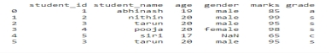
(6, 6)
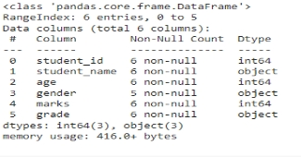
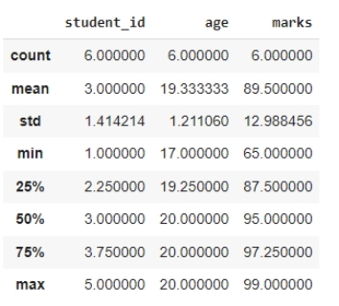

Result:
The dataset was successfully imported, analyzed, and summarized using Python libraries.
Basic statistics and data characteristics were computed successfully.

